

**Computer Systems Engineering Technology**

**CST 120 – Embedded C Programming**

|  |  |
| --- | --- |
| Lab 02 – More LED Fun plus DACs | Name :_Chris Thomas____ |
|  | Due Date: 4/8/2022 11:59PM |
| Instructor: G Drouant | |
| Possible Points: 100 | |

# Purpose

The purpose of this lab is to give you practice using structs, introduce D/A Converters, plot experimental data.

# Hardware Setup

In last week’s lab, you connected an LED to digital pin 12. This week you need to connect LEDs to pins 8, 9, 10, and 11. Arrange your LEDs so that they are all in a row. Digital Pin 8 is connected to LED0, Digital Pin 9 is connected to LED1, Digital Pin 10 is connected to LED2, and Digital Pin 11 is connected to LED3. Schematic diagram is on the next page. All four resistors are 1K. Chose any color LEDs you like – I choose red ones.

*Be sure your board is powered off while doing the wiring.

******Have your lab instructor check you’re wiring before you power your board on.******

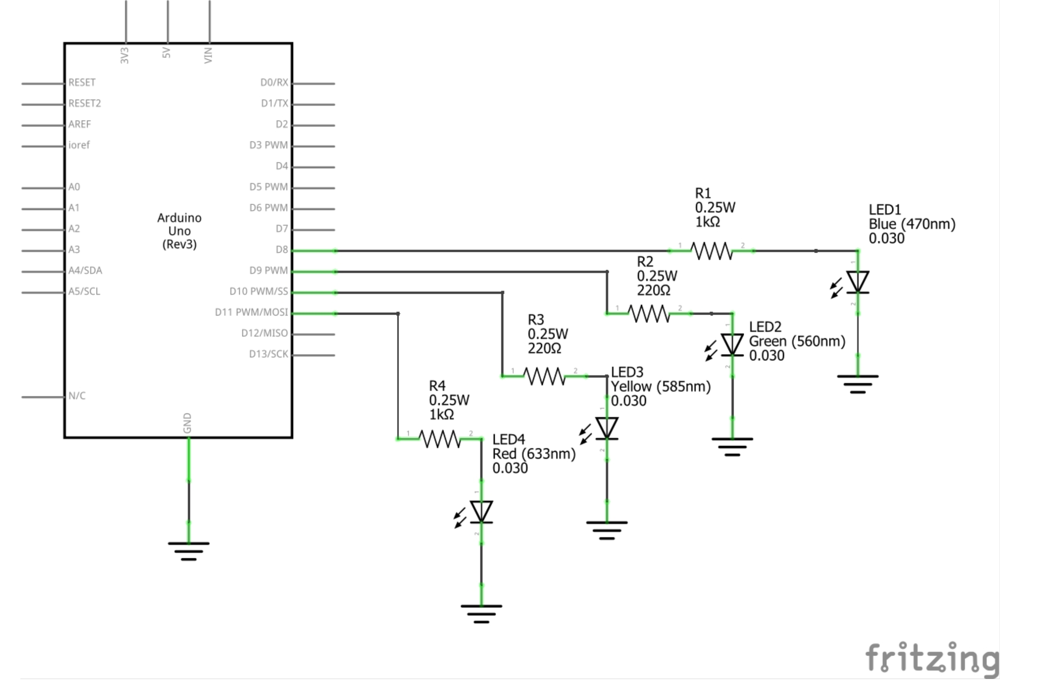

# 

# Gather Info

Last week you were told how to control the LED. This week you will figure out how to control each of the four LEDs from software. They are connected to a single port (PORT B). The information supplied with last week’s lab, Monday’s lecture, and a little ingenuity should be enough to figure this out.

# Part 1

Write a program that repeatedly turns LEDs 0 and 2 on for 1 second, turns those LEDs off and turns on LEDs 1 and 3 on for one second – just like the code presented in Monday’s lecture. You can use one of the programs from Monday’s lecture in this part of the lab. The purpose of this step is to convince yourself that you have correctly assembled your hardware and that your code is working.

**Part 1 Signoff _________1.414________________**

# Part 2

Your LEDs will represent binary bits 2^0 to 2^3 with the least significant bit (lsb) connected to Digital Pin 8 of the UNO Board and the most significant bit (msb) connected to Digital Pin 11. Write a program that will light up the LEDs as the program counts from 0x00 up to 0x0F. When the count starts, it starts at count 0x00. All of the LEDs will be off. The next count (0x01) will turn on the LED representing the lsb or 0x01. The count will continue until all of the LEDs are illuminated indicating a count of 0x0F. The count will then repeat (forever). Place a five second delay between each count.

Modify one of the programs from Monday’s lecture to accomplish this goal.

**Part 2 Signoff _________1.414___________**

# Part 3

Disconnect the UNO from the USB cable and remove the components of the last experiment from the protoboard. Construct the circuit shown on the net page. It is called an “R – 2R Ladder.” It is the heart of a device known as a Digital to Analog Converter (D/A or DAC). Numbers in the form of binary numbers are the inputs to a DAC. The DAC produces an ANALOG output voltage the magnitude of which is a function of the input number. In our circuit the output voltage will be within the range of 0V to 5V (approximately). DACs are useful in producing control signals used to control various devices such as HPLC buffer pumps.

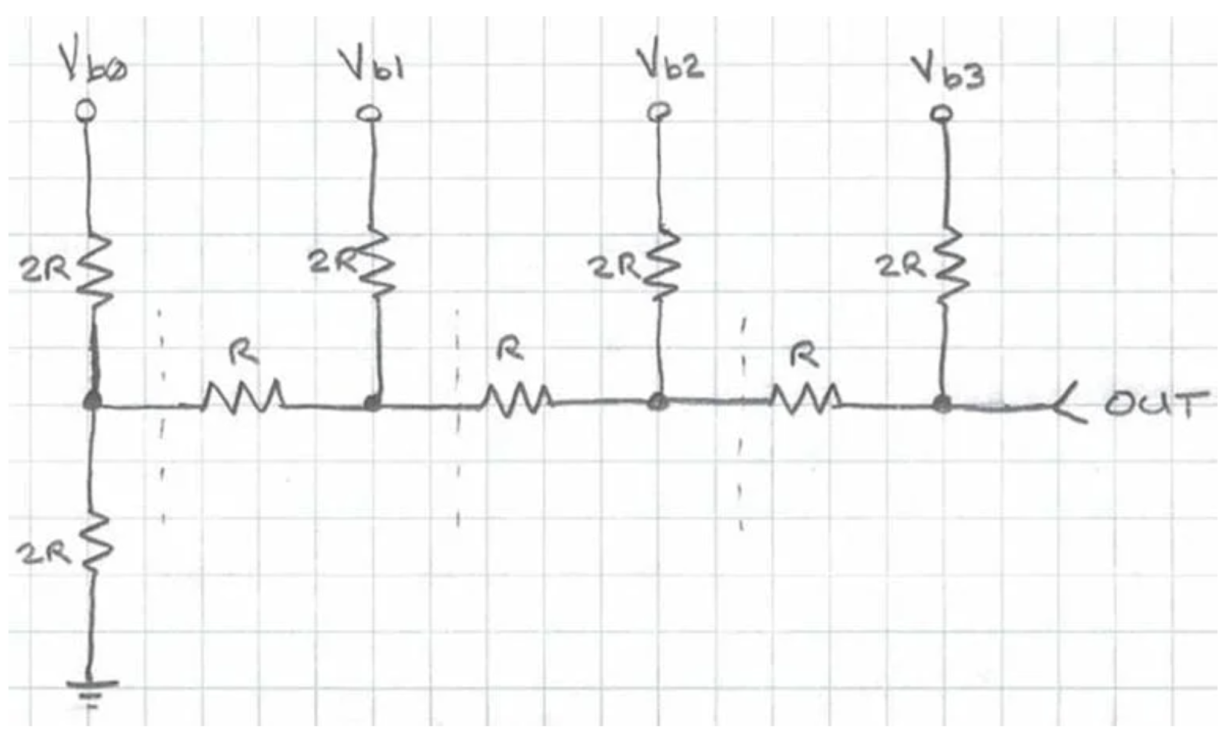

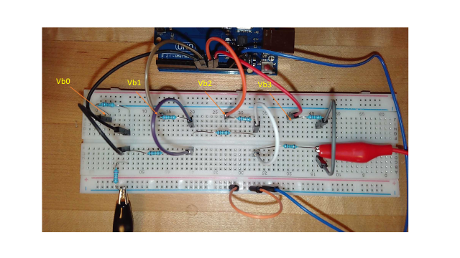

Find the resistors supplied in your kit. Locate the 1000 ohm (1K) resistors and the 2000 ohm (2K) resistors. The resistors labelled “R” in the schematic represent the 1K resistors. The resistors labelled “2R” in the schematic represent the 2K resistors. Digital Pin 8 from the UNO should be attached to point “Vb0” (Voltage bit0). Digital Pin 9 should be connected to Vb1. Digital Pin 10 should be connected to Vb2, and Digital Pin 11 should be connected to Vb3.Vb0, Vb1, Vb2, and Vb3 represent the numbers 2^0, 2^1, 2^2, and 2^3, respectively. Connect the ground of the R-2R ladder to the ground of the UNO.

Using alligator clips connect the RED Probe from the Digital Multimeter (DMM) to “OUT” of the DAC and the BLACK Probe from the DMM to ground. Turn on the DMM to the DC Voltage selection. Plug the USB cable into the UNO. The counter section of the program will then count from 0x00 to 0x0F with delays of 5 seconds between each count. The first voltage value in the counting sequence should be very close to 0V. Record the voltages at each count in the table below:

|  |  |  |  |  |  |
| --- | --- | --- | --- | --- | --- |
| decimal equivalent | bit0 (lsb) | bit1 | bit2 | bit3 (msb) | Observed Vout |
| 0 | 0 | 0 | 0 | 0 | 0 |
| 1 | 1 | 0 | 0 | 0 | .2 |
| 2 | 0 | 1 | 0 | 0 | .5 |
| 3 | 1 | 1 | 0 | 0 | .8 |
| 4 | 0 | 0 | 1 | 0 | 1.2 |
| 5 | 1 | 0 | 1 | 0 | 1.5 |
| 6 | 0 | 1 | 1 | 0 | 1.8 |
| 7 | 1 | 1 | 1 | 0 | 2.1 |
| 8 | 0 | 0 | 0 | 1 | 2.4 |
| 9 | 1 | 0 | 0 | 1 | 2.6 |
| 10 | 0 | 1 | 0 | 1 | 2.9 |
| 11 | 1 | 1 | 0 | 1 | 3.2 |
| 12 | 0 | 0 | 1 | 1 | 3.6 |
| 13 | 1 | 0 | 1 | 1 | 3.9 |
| 14 | 0 | 1 | 1 | 1 | 4.2 |
| 15 | 1 | 1 | 1 | 1 | 4.5 |

Use the following equation to calculate the Vout that “should have been observed” – the Theoretical Vout.

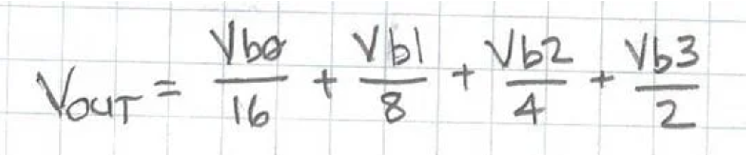

When bit 0 = 0, Vb0 = 0V, When bit 0 = 1, Vb0 = 5V; When bit 1 = 0, Vb1 =0V, When bit 1 =1, Vb1 = 5V

When bit 2 = 0, Vb2 = 0V, When bit 2 = 1, Vb2 = 5V; When bit 3 = 0, Vb3 =0V, When bit 3 =1, Vb3 = 5V

**How to calculate the Theoretical Value of Vout:**

Using the equation from the previous page if Vb0 = 5V, Vb1 = 0V, Vb2=0V, and Vb3 = 0V ---- Vout = (5/16)+(0/8)+(0/4)+(0/2) = 0.3125V.

Those voltage values will occur at a count of 0x01 = 0001 ---- decimal equivalent = 1.

Calculate and Record the Theoretical Vout value in the table below:

|  |  |  |  |  |  |
| --- | --- | --- | --- | --- | --- |
| decimal equivalent | bit0 (lsb) | bit1 | bit2 | bit3 (msb) | Theoretical Vout |
| 0 | 0 | 0 | 0 | 0 | 0 |
| 1 | 1 | 0 | 0 | 0 | 0.312 |
| 2 | 0 | 1 | 0 | 0 | 0.625 |
| 3 | 1 | 1 | 0 | 0 | 0.937 |
| 4 | 0 | 0 | 1 | 0 | 1.25 |
| 5 | 1 | 0 | 1 | 0 | 1.56 |
| 6 | 0 | 1 | 1 | 0 | 1.87 |
| 7 | 1 | 1 | 1 | 0 | 2.18 |
| 8 | 0 | 0 | 0 | 1 | 2.5 |
| 9 | 1 | 0 | 0 | 1 | 2.81 |
| 10 | 0 | 1 | 0 | 1 | 3.12 |
| 11 | 1 | 1 | 0 | 1 | 3.43 |
| 12 | 0 | 0 | 1 | 1 | 3.75 |
| 13 | 1 | 0 | 1 | 1 | 4.06 |
| 14 | 0 | 1 | 1 | 1 | 4.37 |
| 15 | 1 | 1 | 1 | 1 | 4.68 |

Plot the Observed Vout versus the decimal equivalent of the number input into the DAC (I suggest using Excel). Do a linear fit to the Observed Vout data points displaying the equation and R^2 value on the graph. Next, plot the Theoretical Vout values that you calculated on the same graph. Use different colors for the two different data sets (the Observed versus the Theoretical). Do the two sets of data match or not?_ not perfectly because of variation with resistors and voltage.

See the plots of the Observed and Theoretical Vouts that I obtained in the flowing graph.

Be sure your source code complies with the CSET coding standard. Demo your project to the lab instructor. He will sign you off on the check off sheet. Next upload a digital copy of your project (main.c and define.h), the lab handout Word Document and your graph onto the canvas site.

**Part 3 Signoff**____________1.414_____________________